Tooth Eruption Dates
It's important to note that eruption times vary form child to child just as the individual growth rates between children vary. Normally, no teeth are visible in the mouth at birth. Occasionally, however, some babies are born with an erupted incisor (neonatal tooth), but these are not true teeth and are lost soon after birth.
The first baby teeth to erupt are usually the lower two front incisors (mandibular central incisors) at about 6 months of age. They are followed by the 4 upper front teeth. The remainder of your child's teeth will appear periodically, usually in pairs on each side of the jaw, until all 20 baby teeth have come in at about 2 1/2 years of age. The last teeth to emerge are the top two molars (maxillary second molars at 30 months). The complete set of baby teeth are in the mouth from 2 years to 5 3/4 or 6 years of age (when no permanent teeth are present). Shortly after your child's 4th birthday, their jaw and facial bones will begin to grow creating spaces between their teeth. This is frequently a concern to parents, but it’s a perfectly natural process of providing the necessary space for the larger permanent teeth to emerge.
A good rule of thumb concerning baby teeth is that for every 6 months, approximately 4 teeth will erupt. So, if your child is 12 months, you should expect 8 teeth.
Though baby teeth are only in the mouth for a short time, they play a vital role in reserving space for their permanent counterparts. The primary teeth are crucial to your child's normal facial appearance and the formulation of clear speech. Missing or decayed baby teeth often cause children to reject foods that are difficult to chew. Decay and infection in baby teeth can cause dark spots on the permanent tooth developing beneath it.
The following diagram shows approximately when each baby tooth should erupt. Many variations occur, but the usual order of appearance is as follows
Eruption Patterns
- Teeth tend to erupt in pairs.
- Lower teeth usually erupt before the upper teeth
- Girls generally preceded boys in tooth eruption
The teeth in both jaws usually erupt in pairs - one on the right and one on the left.
By the time the child reaches the age of two to three years, all the deciduous (baby) teeth should have erupted.
Eruption Dates for Baby Teeth
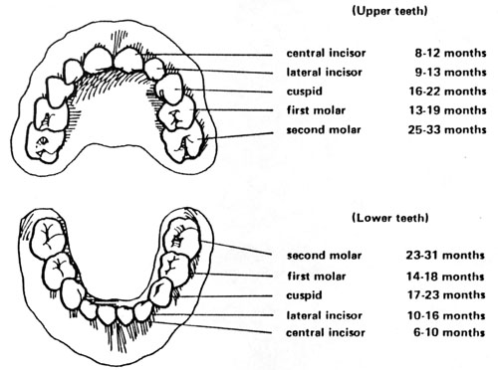
Permanent Teeth
At about 6 years of age, the first permanent molars (upper and lower) and lower permanent incisors begin to erupt. Between the age of approximately 6 and 12 years, children have a mixture of permanent and deciduous teeth. This is known as the mixed dentition stage. By the age of 12 most children have all their permanent teeth, except for their wisdom teeth.
Eruption Dates for Permanent Teeth

